|  |  |  |  |  |  |  |  |  |  |
| --- | --- | --- | --- | --- | --- | --- | --- | --- | --- |
| Galileo Desktop  Version 2.5 | | | | | | | | | |
| Product Advisory Number: | 1197 | | | | | | | | |
| Version: | 01 | | | | | | | | |
| Internally Available | 5 July 2011 | |  | |  | |  | |  |
|  | | | | | | | | | |
| High Level Description: | Support for Internet Explorer 9, plus three small enhancements from the regional priority list | | | | | | | | |
|  | | | | | | | | | |
| Impact Summary: | Regional product teams need to make this available to NDCs and end user customers | | | | | | | | |
|  | | | | | | | | | |
| Reason For Issue: | First Notification | | | | | | | | |
|  | | | | | | | | | |
| Customer Impact: |  | Internal Only | |  | | Developers | | | |
|  | Agency Customers | |  | | Airline Customers | | | |
|  | eCommerce Customers | |  | | Car, Hotel, Rail or Cruise Customers | | | |
|  | | | | | | | | | |
| System: |  | Galileo | | | | | | | |
|  | Apollo | | | | | | | |
|  | Worldspan | | | | | | | |
|  | | | | | | | | | |
| Load To Copy: | Not Applicable | | <Include US EASTERN STANDARD TIME format NN:NN (24 Hour Clock).> | | EST | | | <Include GREENWICH MEAN TIME format NN:NN (24 Hour Clock).> | GMT |
| Web Services: (API and Messaging) | Not applicable | | | | | | | | |
|  | | | | | | | | | |
| Issue History: | <Leave blank. Will be completed as part of the Ask Travelport uploading process and relates to the actual date this advisory (and subsequent versions) was sent to external customers.> | | | | | | | | |
| Contact: | <Leave blank. This section will be completed by Product Management. Text is in red to denote downstream removal before external customer notification. Customers are advised to contact Travelport through their Account Manager.> | | | | | | | | |

# Overview

This release of Galileo Desktop contains the following enhancements:

* Internet Explorer 9 compatibility
* Viewpoint support for enhanced hotel room and rule data, as well as Enhanced Best Available Rate (EBAR)
* Point and Click support for the net fare modifier with fare display (1G Only)
* Manual DOCO/DOCA/DOCS SSR support
* Desktop SDK - Host Command:: MakeEntry can now be used to submit a terminal transaction to a specific Client ID/GTID. (See Desktop SDK for details)

# Detail and Customer Examples

**Hotel Enhancements**

Enhanced hotel response data (see Product Advisory 1113). Inside Availability suppliers (and above) can return key room, rule and rate data that was previously restricted to Complete Pricing Plus participants.

When requesting a complete availability for participating hotels, agents can view additional details by clicking the “Additional Detail” button.

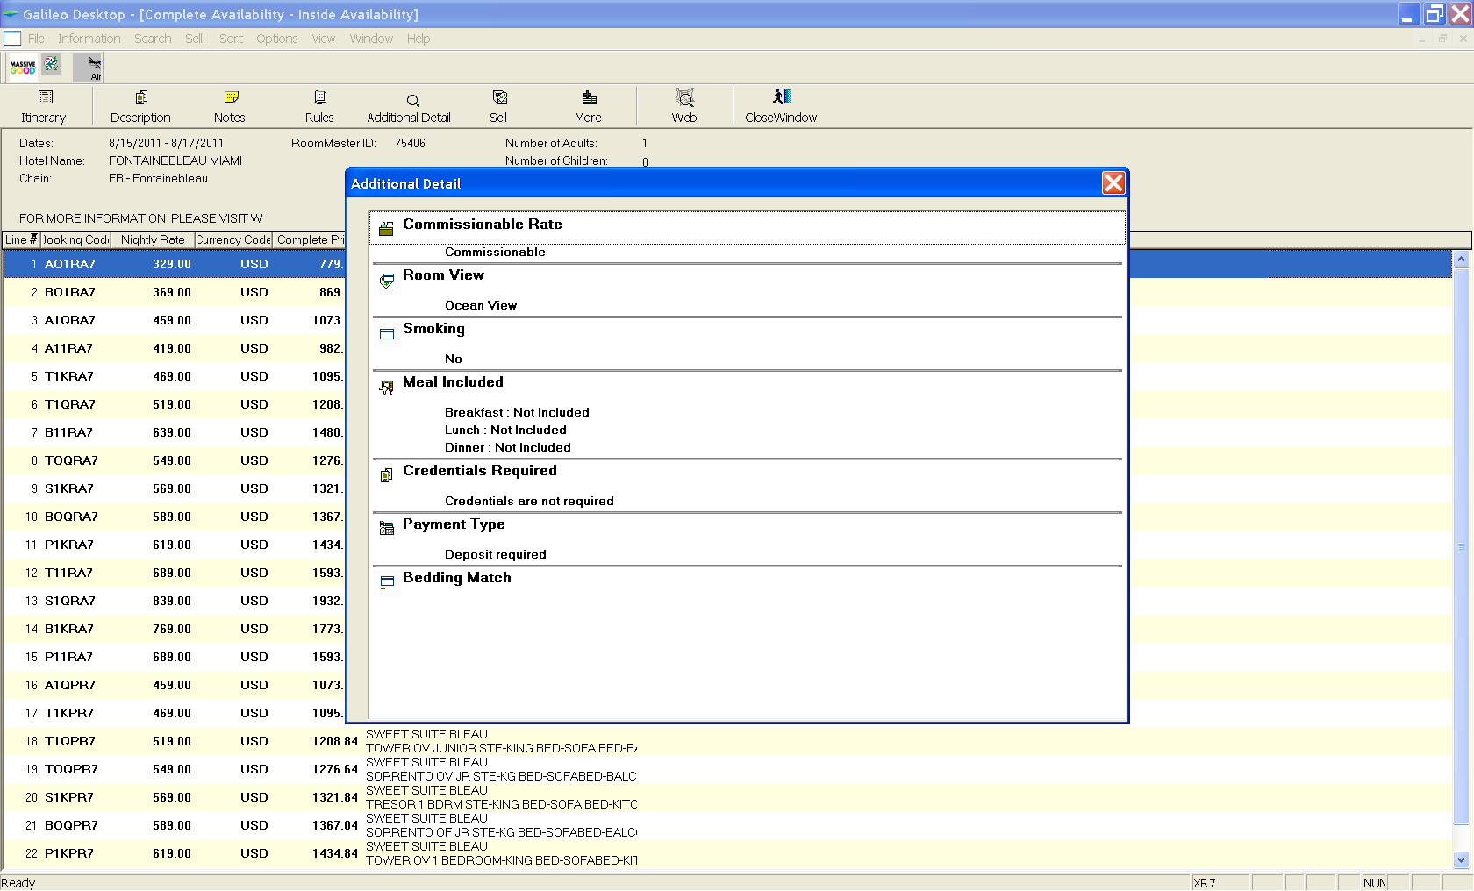

The RoomMaster Best Available Rate (BAR) program has been enhanced to include a higher level of participation in which chain participants agree to provide Travelport users with access to their lowest public rates - both restricted and unrestricted rates.

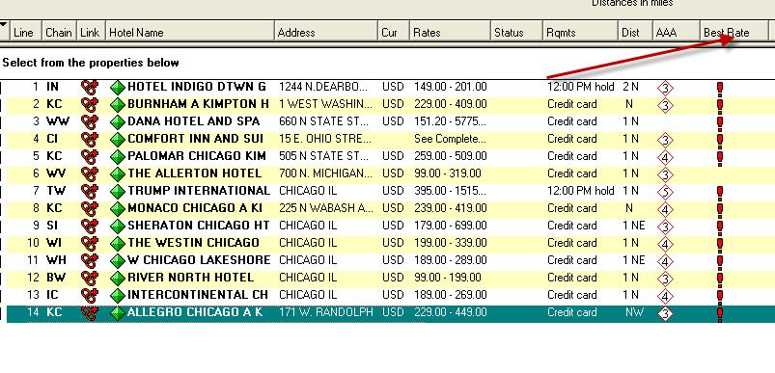

When applicable, a “lowest public rate” indicator will appear in the “Best Rate” columns.



**Point and Click**

Point and Click now supports the net fare modifier, “**:C**”. Note: there will be no additional enhancements to the Point and Click product. The enhanced version of Point and Click, *Smartpoint,* will be available in 4Q11.

**SSR DOC Entries**

On July 25, SSR Doc entries will no longer be programmatic SSRs, and require name selection only. As a reminder, when modifying an SSR in Viewpoint, first delete the original SSR from the list, then add the new SSR.

# Internal Only Information

N/A

**Glossary**

|  |  |
| --- | --- |
| Term | Definition |
|  |  |

**THE INFORMATION CONTAINED IN THIS DOCUMENT IS CONFIDENTIAL AND PROPRIETARY TO TRAVELPORT**

**Copyright**

Copyright © Travelport and/or its affiliates. All rights reserved.

Travelport provides this document for information purposes only and does not promise that the information contained in this document is accurate, current or complete. This document is subject to change without notice. No part of this document may be reproduced, stored in a retrieval system, or transmitted in any form or any means electronic or mechanical, including photocopying and recording for any purpose other than the licensee’s personal use without the prior written permission of Travelport and/or its affiliates.

**Trademarks**

Travelport and/or its affiliates may have registered or unregistered patents or pending patent applications, trademarks copyright, or other intellectual property rights in respect of the subject matter of this document. The furnishing of this document does not confer any right or license to or in respect of these patents, trademarks, copyright, or other intellectual property rights.

All other companies and product names are trademarks or registered trademarks of their respective holders.